
LILLINGTON
PRESBYTERIAN
CHURCH

October 13, 2024
Twenty-first Sunday after Pentecost
† You are invited to stand when you see this symbol.

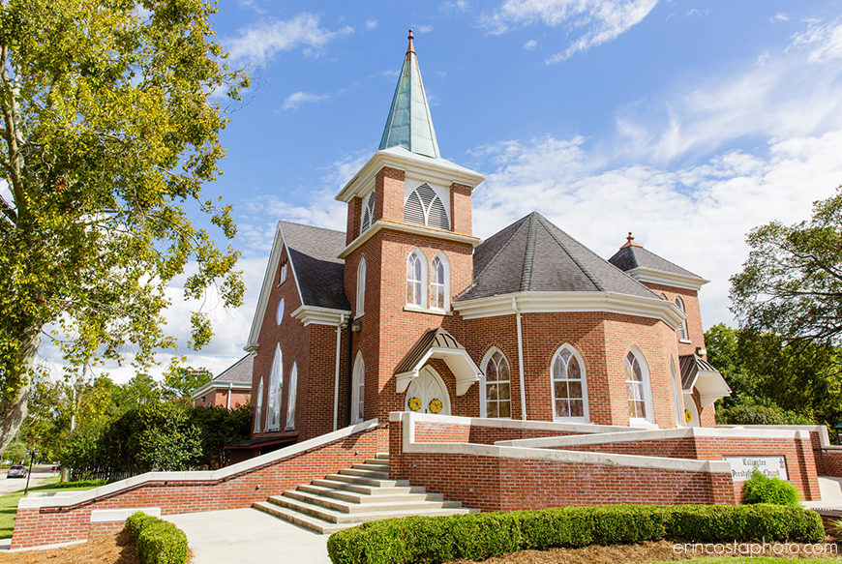

PRELUDE On Holy, Holy Ground

WELCOME AND OUR LIFE TOGETHER

† CALL TO WORSHIP
Leader: We gather before God together, imperfect but present.
People: Let us worship God together earnestly,
with our whole selves.
We gather before God together, desiring deeper faith.
Let us learn from God together as we seek
harmony between our words and our actions.

† HYMN #475 Come, Thou Fount of Every Blessing _{NETTLETON}

† CALL TO CONFESSION
† PRAYER OF CONFESSION
(silent prayer)
We know the commandments:
You shall not murder;
you shall not commit adultery;
you shall not steal;
honor your father and your mother.

We are sure we follow them, but instead, we cannot let go of the things
we think we need or what we think is important.
We do not follow you, or love you, O God, with all our hearts, our
minds, our strength. We refrain from giving our whole selves to you.

Forgive our disobedience, our lack of commitment, and our desire to
focus on material things instead of on your will for us.
In the name of our Teacher, Jesus Christ. Amen.

† ASSURANCE OF PARDON
We do not have a high priest who is unable to sympathize
with our weakness, but we have one who in every respect
has been tested as we are, yet without sin.
Therefore, you can approach the throne of grace with boldness,
and find grace in your time of need.
Thanks be to God.

† PASSING OF THE PEACE
May the peace of Christ be with you.
And also with you.

† RESPONSE OF PRAISE Glory to God
Glory to God, whose goodness shines on me,
and to the Son, whose grace has pardoned me,
and to the Spirit, whose love has set me free.
As it was in the beginning, is now and ever shall be. A-men.
World without end, without end. A-men. (3x)
As it was in the beginning, is now and ever shall be. A-men.

FAITH SHARING WITH CHILDREN

PRAYER OF ILLUMINATION

OLD TESTAMENT LESSON Job 23:1-2, 8-9, 16-17 _{page 471 OT}

ANTHEM Jesus, the Master Chancel Choir
GOSPEL LESSON Mark 10:17-31 _{page 46 NT}

SERMON “Where’s Your Treasure – In Heaven or On Earth?”
Betty Lou Miller

† HYMN #724 O Jesus, I Have Promised _{ANGEL’S STORY}

† AFFIRMATION OF FAITH Brief Statement of Faith (PCUSA) _{10.3}
We trust in God, whom Jesus called Abba, Father.
In sovereign love God created the world good
and makes everyone equally in God’s image,
male and female, of every race and people,
to live as one community.
But we rebel against God; we hide from our Creator.
Yet God acts with justice and mercy to redeem creation.
Loving us still,
God makes us heirs with Christ of the covenant.
Like a mother who will not forsake her nursing child,
like a father who runs to welcome the prodigal home,
God is faithful still.

INVITATION TO OFFERING AND PRAYER OF DEDICATION

OFFERING MUSIC My Faith Looks Up to Thee

† DOXOLOGY _{DOXOLOGY}
Praise God, from whom all blessings flow;
Praise Him, all creatures here below;
Praise Him above, ye heavenly host;
Praise Father, Son, and Holy Ghost. Amen.

PRAYERS FOR THE PEOPLE AND THE LORD’S PRAYER
...Our Father who art in heaven, hallowed be thy name. Thy kingdom come, thy will be done, on earth as it is in heaven. Give us this day our daily bread; and forgive us our debts, as we forgive our debtors; and lead us not into temptation, but deliver us from evil. For thine is the kingdom and the power and the glory, forever. Amen.

† HYMN #749 Come! Live in the Light! _{WE ARE CALLED}

CHARGE AND BENEDICTION

POSTLUDE O God, You Are My God
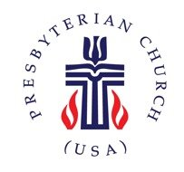
Church Information

Mailing Address: | PO Box 245 Lillington, NC 27546
Phone: | 910-893-3545
Website: | www.lillingtonpres.org
Office Hours: | M-F 9am-1pm

Church Staff
Minister: | Pastor@lillingtonpres.org  910-893-3545
Music Director: Wanda Brown | music@lillingtonpres.org  910-890-0900
Children’s Ministry Director:  Amanda Inguanza | christianed@lillingtonpres.org
Bookkeeper: Miranda Owen | Accounting@lillingtonpres.org
Administrative Asst.:  Paula Stephenson | office@lillingtonpres.org  910-893-3545
Sextons: Rose and Elmon Pipkin, Jr
Session
Moderator: Rev. David Smithey
Clerk: Jim Cruickshank

Class of 2024 | Class of 2025 | Class of 2026
Derrick graham | James cox | Al Bain
Susan ashworth | Bonnie cruickshank | Christine Cox
Ray collins | Lynn nash | Chris Newcomb
Brenda langdon | Steve plummer | Jeff Paschal

Search Lillington Presbyterian Church on your favorite podcast provider
for more sermons and series.

